Ahmad Barakat | ITEC 422 | Wireshark Lab 6

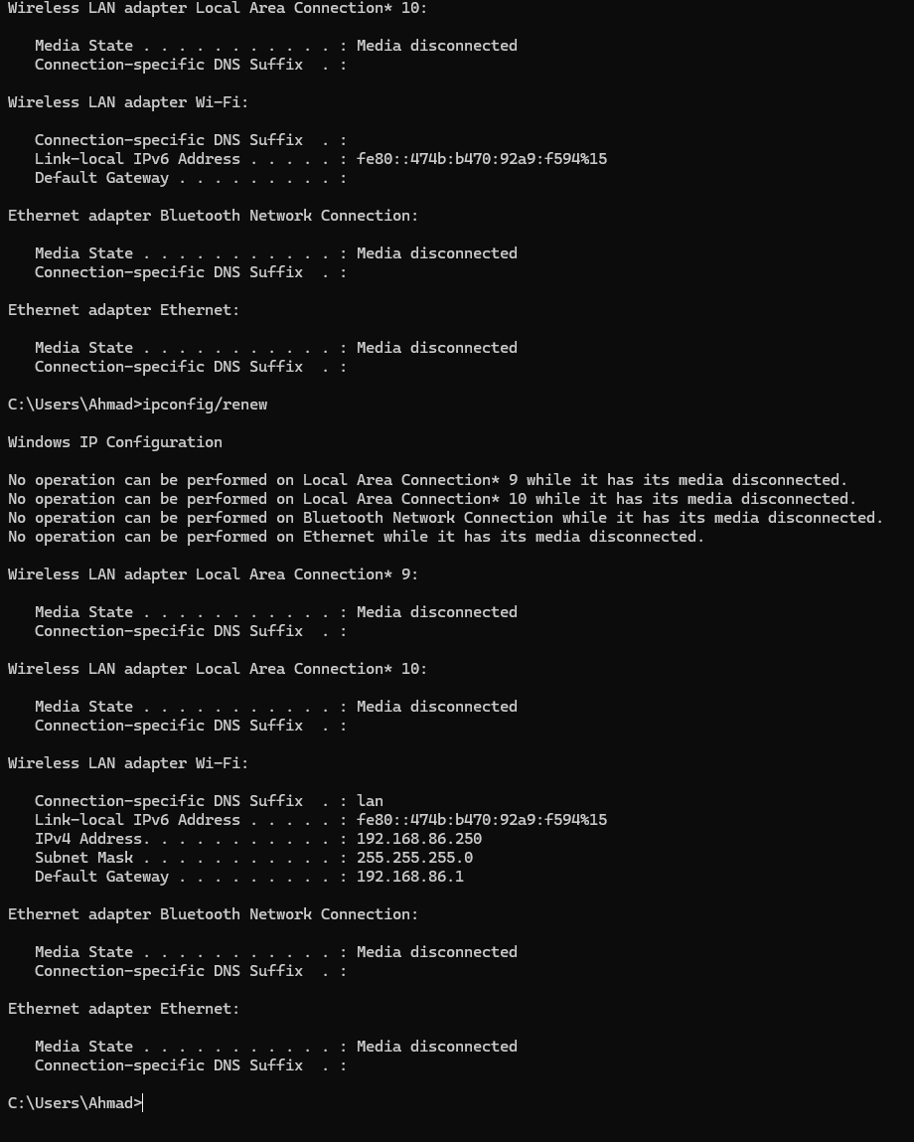

- DHCP messages use UDP for ports 67 and 68.

- Discover: src port 68, dest port 67
Offer: src port 67, dest port 68
Request: src port 68, dest port 67
ACK: src port 67, dest port 68
Yes, it is the same as the default within the lab
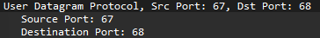

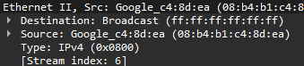

- Client IP Address
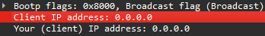
Discover:

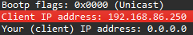
Request:

- Discover: 0x67e70e49
Offer: 0xe5a93d1d
Request: 0x13627219
ACK: 0x13627219
Request: 0xaa7326e5
ACK: 0xaa7326e5
Identifies a transaction so that it can be tracked and matched to records in the system.

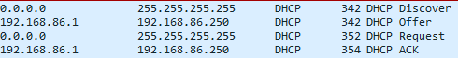

- in Offer message
- No relay agent.
- Router - Default gateway for client.
Subnet mask - network portion of IP
- Yes, can be found in request at
- How long client can use an IP before having to renew
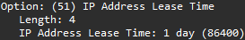
- Client releases IP before lease expires, no request is not acknowledged, if DHCP release is lost then server will regain IP after lease expires.
- Yes, check if a certain IP is being used.

